# Slot11_ex2

## Nvbar.js



import React from 'react';

import { Navbar as BootstrapNavbar, Nav, Form, FormControl, Container } from 'react-bootstrap';

import { useState } from 'react';

function Navbar({ onQuickSearch }) {

    const [searchTerm, setSearchTerm] = useState('');

    const handleSearch = (e) => {

        setSearchTerm(e.target.value);

        onQuickSearch(e.target.value);

    };

    return (

        <BootstrapNavbar bg="dark" variant="dark" expand="lg" sticky="top" className="shadow">

            <Container fluid>

                <BootstrapNavbar.Brand href="#home" className="d-flex align-items-center">

                    <i className="bi bi-people-fill me-2" style={{ fontSize: '1.5rem' }}></i>

                    <span className="fw-bold">Student Management</span>

                </BootstrapNavbar.Brand>

                <BootstrapNavbar.Toggle aria-controls="navbarScroll" className="border-0" />

                <BootstrapNavbar.Collapse id="navbarScroll">

                    <Nav className="me-auto my-2 my-lg-0" style={{ maxHeight: '100px' }} navbarScroll>

                        <Nav.Link href="#home" className="mx-2 px-3 py-2 rounded-3">

                            <i className="bi bi-house-door me-2"></i>

                            Home

                        </Nav.Link>

                        <Nav.Link href="#students" className="mx-2 px-3 py-2 rounded-3">

                            <i className="bi bi-people me-2"></i>

                            Students

                        </Nav.Link>

                        <Nav.Link href="#about" className="mx-2 px-3 py-2 rounded-3">

                            <i className="bi bi-info-circle me-2"></i>

                            About

                        </Nav.Link>

                    </Nav>

                    <Form className="d-flex flex-grow-1 mx-3">

                        <FormControl

                            type="search"

                            placeholder="Search students by name or email..."

                            aria-label="Search"

                            value={searchTerm}

                            onChange={handleSearch}

                            className="rounded-pill px-3"

                            style={{

                                marginLeft: 'auto',

                                maxWidth: '450px',

                                width: '100%'

                            }}

                        />

                    </Form>

                </BootstrapNavbar.Collapse>

            </Container>

        </BootstrapNavbar>

    );

}

export default Navbar;

## Footer.js



import React from 'react';

import { Container, Navbar } from 'react-bootstrap';

function Footer() {

  return (

    <Navbar bg="dark" variant="dark" className="mt-auto py-3">

      <Container>

        <Navbar.Text className="text-center w-100 text-white">

          © {new Date().getFullYear()} Student Management System. All rights reserved.

        </Navbar.Text>

      </Container>

    </Navbar>

  );

}

export default Footer;

## Filters.js

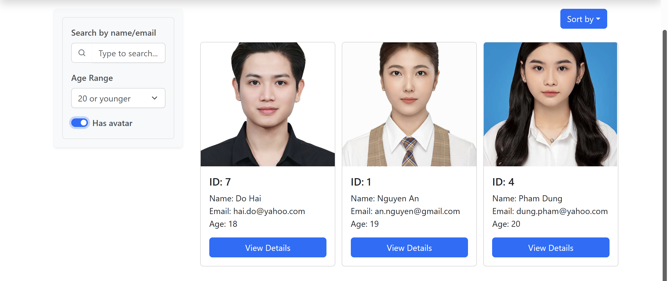

import React, { useState } from 'react';

import { Form, InputGroup } from 'react-bootstrap';

function Filters({ onFilter }) {

  const [searchTerm, setSearchTerm] = useState('');

  const [ageRange, setAgeRange] = useState('all');

  const [hasAvatar, setHasAvatar] = useState(false);

  const handleFilter = () => {

    onFilter({ searchTerm, ageRange, hasAvatar });

  };

  return (

    <Form className="p-3 border rounded" style={{

      maxWidth: '400px',

      backgroundColor: '#f8f9fa',

      borderColor: '#dee2e6'

    }}>

      {/* Search Field */}

      <Form.Group controlId="formSearch" className="mb-3">

        <Form.Label className="fw-semibold" style={{ color: '#495057' }}>

          Search by name/email

        </Form.Label>

        <InputGroup>

          <InputGroup.Text style={{

            backgroundColor: '#fff',

            borderColor: '#ced4da'

          }}>

            <svg width="16" height="16" viewBox="0 0 16 16" fill="#6c757d">

              <path fillRule="evenodd" d="M11.5 7a4.5 4.5 0 11-9 0 4.5 4.5 0 019 0zm-.82 4.74a6 6 0 111.06-1.06l2.79 2.79a.75.75 0 11-1.06 1.06l-2.79-2.79z" clipRule="evenodd"/>

            </svg>

          </InputGroup.Text>

          <Form.Control

            type="text"

            placeholder="Type to search..."

            value={searchTerm}

            onChange={(e) => {

              setSearchTerm(e.target.value);

              handleFilter();

            }}

            style={{

              borderLeft: 'none',

              boxShadow: '0 1px 2px rgba(0,0,0,0.05)',

              borderColor: '#ced4da'

            }}

          />

        </InputGroup>

      </Form.Group>

      {/* Age Range Select */}

      <Form.Group controlId="formAgeRange" className="mb-3">

        <Form.Label className="fw-semibold" style={{ color: '#495057' }}>

          Age Range

        </Form.Label>

        <Form.Select

          value={ageRange}

          onChange={(e) => {

            setAgeRange(e.target.value);

            handleFilter();

          }}

          style={{

            boxShadow: '0 1px 2px rgba(0,0,0,0.05)',

            borderColor: '#ced4da',

            color: '#495057'

          }}

        >

          <option value="all">All students</option>

          <option value="<=20">20 or younger</option>

          <option value="21-25">21 to 25 years</option>

          <option value=">25">Over 25 years</option>

        </Form.Select>

      </Form.Group>

      {/* Avatar Toggle */}

      <Form.Group controlId="formHasAvatar">

        <Form.Check

          type="switch"

          id="avatar-switch"

          label={

            <span className="fw-semibold" style={{ color: '#495057' }}>

              Has avatar

            </span>

          }

          checked={hasAvatar}

          onChange={(e) => {

            setHasAvatar(e.target.checked);

            handleFilter();

          }}

          style={{

            '--bs-form-switch-bg': 'url("data:image/svg+xml,%3csvg xmlns=%27http://www.w3.org/2000/svg%27 viewBox=%27-4 -4 8 8%27%3e%3ccircle r=%273%27 fill=%27%23fff%27/%3e%3c/svg%3e")',

            '--bs-form-switch-border-color': '#adb5bd',

            '--bs-form-switch-bg-color': '#6c757d'

          }}

        />

      </Form.Group>

    </Form>

  );

}

export default Filters;

## SortDropdown.js

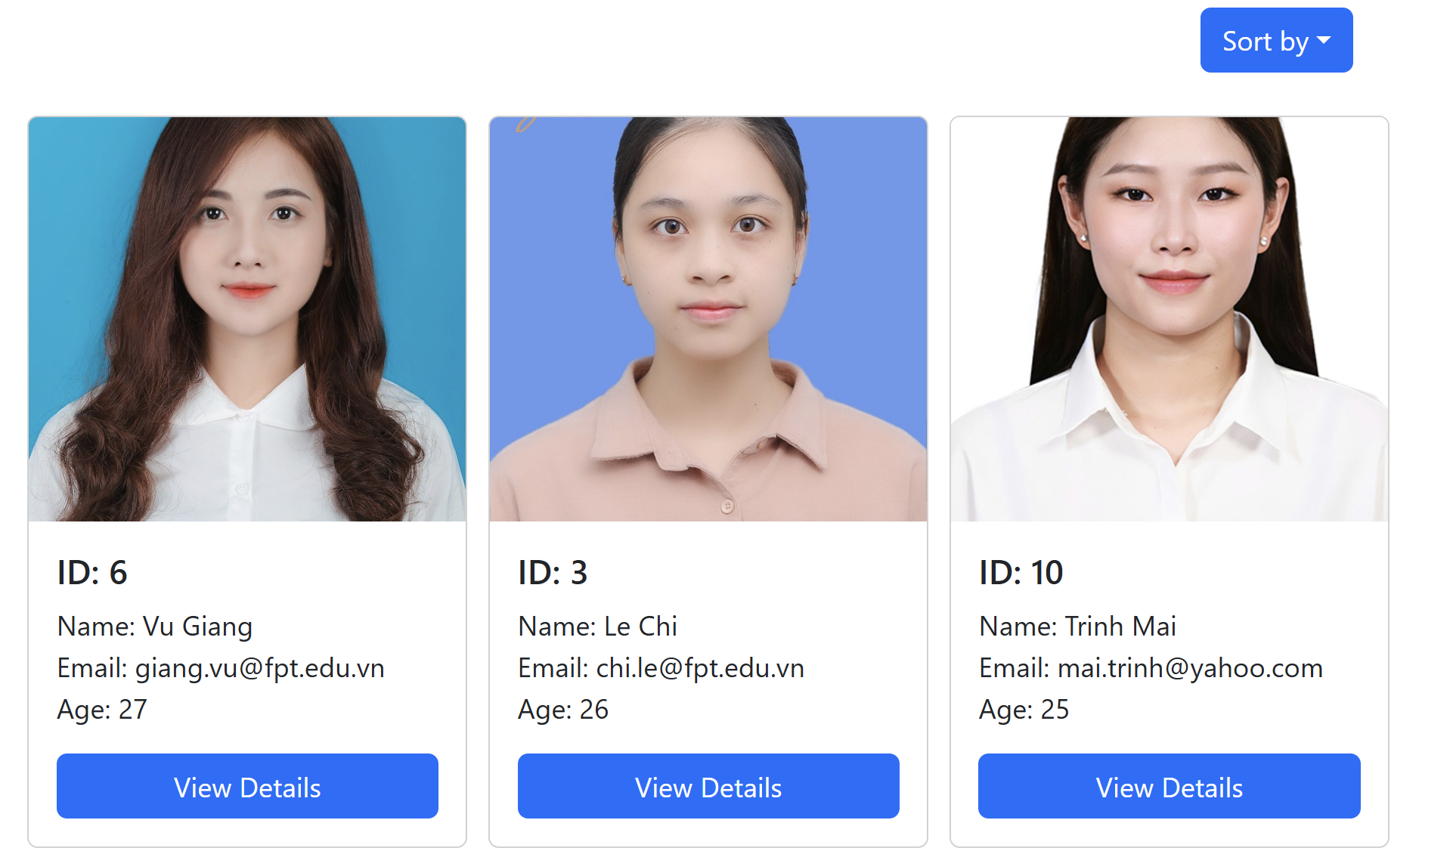

import React, { useState } from 'react';

import { Dropdown } from 'react-bootstrap';

function SortDropdown({ onSort }) {

  const [sortOption, setSortOption] = useState('nameAsc');

  const handleSort = (option) => {

    setSortOption(option);

    onSort(option);

  };

  return (

    <Dropdown className="mb-3 text-end">

      <Dropdown.Toggle variant="primary" id="dropdown-basic">

        Sort by

      </Dropdown.Toggle>

      <Dropdown.Menu>

        <Dropdown.Item onClick={() => handleSort('ageAsc')}>Age ↑</Dropdown.Item>

        <Dropdown.Item onClick={() => handleSort('ageDesc')}>Age ↓</Dropdown.Item>

        <Dropdown.Item onClick={() => handleSort('nameAsc')}>Name A-Z</Dropdown.Item>

        <Dropdown.Item onClick={() => handleSort('nameDesc')}>Name Z-A</Dropdown.Item>

      </Dropdown.Menu>

    </Dropdown>

  );

}

export default SortDropdown;

## StudentCard.js

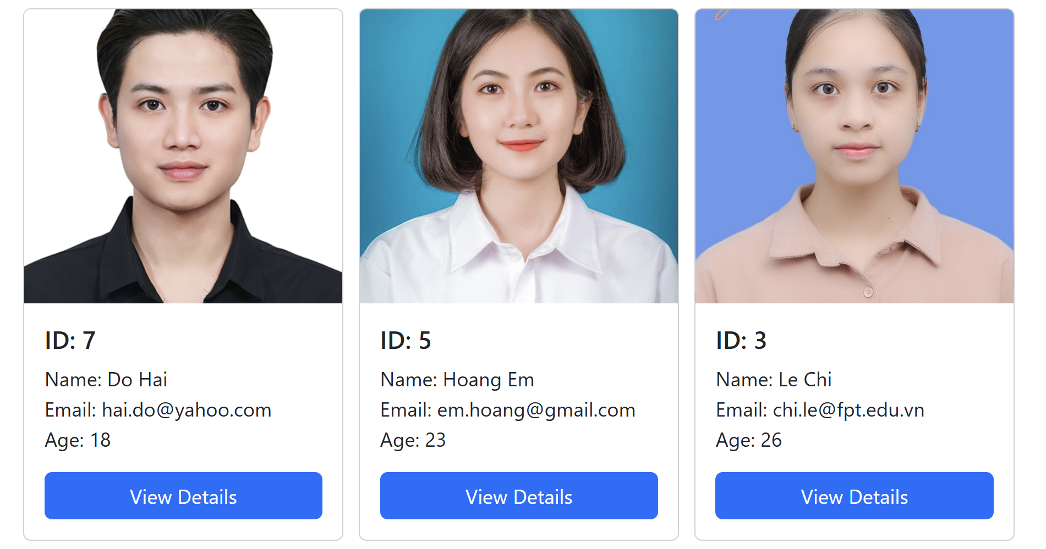

import React from 'react';

import { Card } from 'react-bootstrap';

import PropTypes from 'prop-types';

function StudentCard({ student, onViewDetails }) {

  return (

    <Card style={{ width: '16rem', height: '97%', margin: '10px', display: 'flex', flexDirection: 'column', }}>

      <Card.Img variant="top" src={student.avatar || 'https://via.placeholder.com/150'} style={{ width: '100%', height: '250px', objectFit: 'cover' }} />

      <Card.Body style={{ flex: '1', display: 'flex', flexDirection: 'column', justifyContent: 'space-between' }}>

        <div>

          <Card.Title>ID: {student.id}</Card.Title>

          <Card.Text>

            Name: {student.name}<br />

            Email: {student.email}<br />

            Age: {student.age}

          </Card.Text>

        </div>

        <button onClick={() => onViewDetails(student)} style={{ width: '100%', marginTop: '10px' }} className="btn btn-primary">

          View Details

        </button>

      </Card.Body>

    </Card>

  );

}

StudentCard.propTypes = {

  student: PropTypes.shape({

    id: PropTypes.number.isRequired,

    name: PropTypes.string.isRequired,

    email: PropTypes.string.isRequired,

    age: PropTypes.number.isRequired,

    avatar: PropTypes.string,

  }).isRequired,

  onViewDetails: PropTypes.func.isRequired,

};

export default StudentCard;

## StudentDetailModal.js

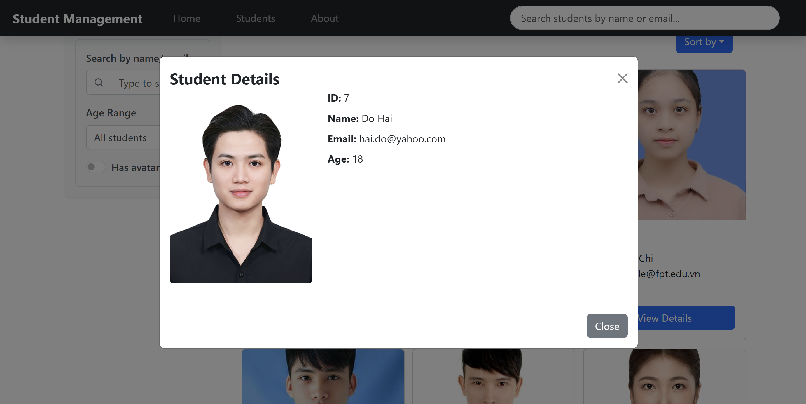

import React from 'react';

import { Modal, Button, Image } from 'react-bootstrap';

function StudentDetailModal({ show, onHide, student }) {

  return (

    <Modal show={show} onHide={onHide} centered size="lg">

      <Modal.Header closeButton className="border-0 pb-0">

        <Modal.Title className="fw-bold">Student Details</Modal.Title>

      </Modal.Header>

      <Modal.Body className="pt-0">

        <div className="row">

          <div className="col-md-4 text-center">

            <Image

              src={student.avatar || 'https://via.placeholder.com/300'}

              alt={student.name}

              fluid

              rounded

              className="mb-3"

            />

          </div>

          <div className="col-md-8">

            <ul className="list-unstyled">

              <li className="mb-2"><strong>ID:</strong> {student.id}</li>

              <li className="mb-2"><strong>Name:</strong> {student.name}</li>

              <li className="mb-2"><strong>Email:</strong> {student.email}</li>

              <li className="mb-2"><strong>Age:</strong> {student.age}</li>

            </ul>

          </div>

        </div>

      </Modal.Body>

      <Modal.Footer className="border-0">

        <Button variant="secondary" onClick={onHide}>

          Close

        </Button>

      </Modal.Footer>

    </Modal>

  );

}

export default StudentDetailModal;

## StudentGrid.js

import React from 'react';

import StudentCard from './StudentCard';

function StudentGrid({ students, onViewDetails }) {

  return (

    <div className="row">

      {students.map((student) => (

        <div key={student.id} className="col-12 col-md-6 col-lg-4">

          <StudentCard student={student} onViewDetails={onViewDetails} />

        </div>

      ))}

    </div>

  );

}

export default StudentGrid;

## StudentsPage.js

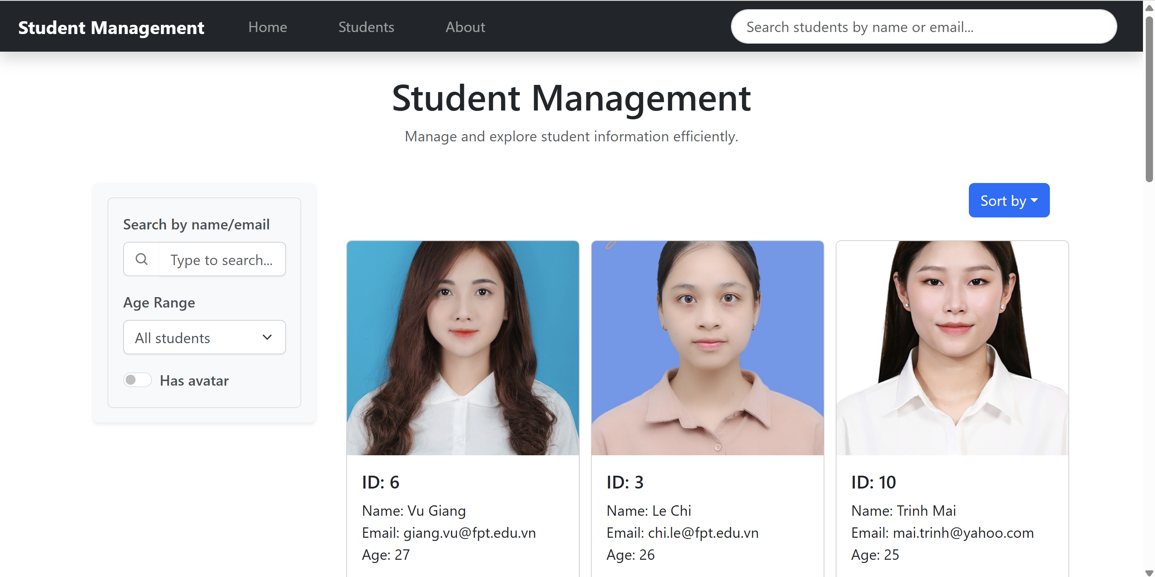

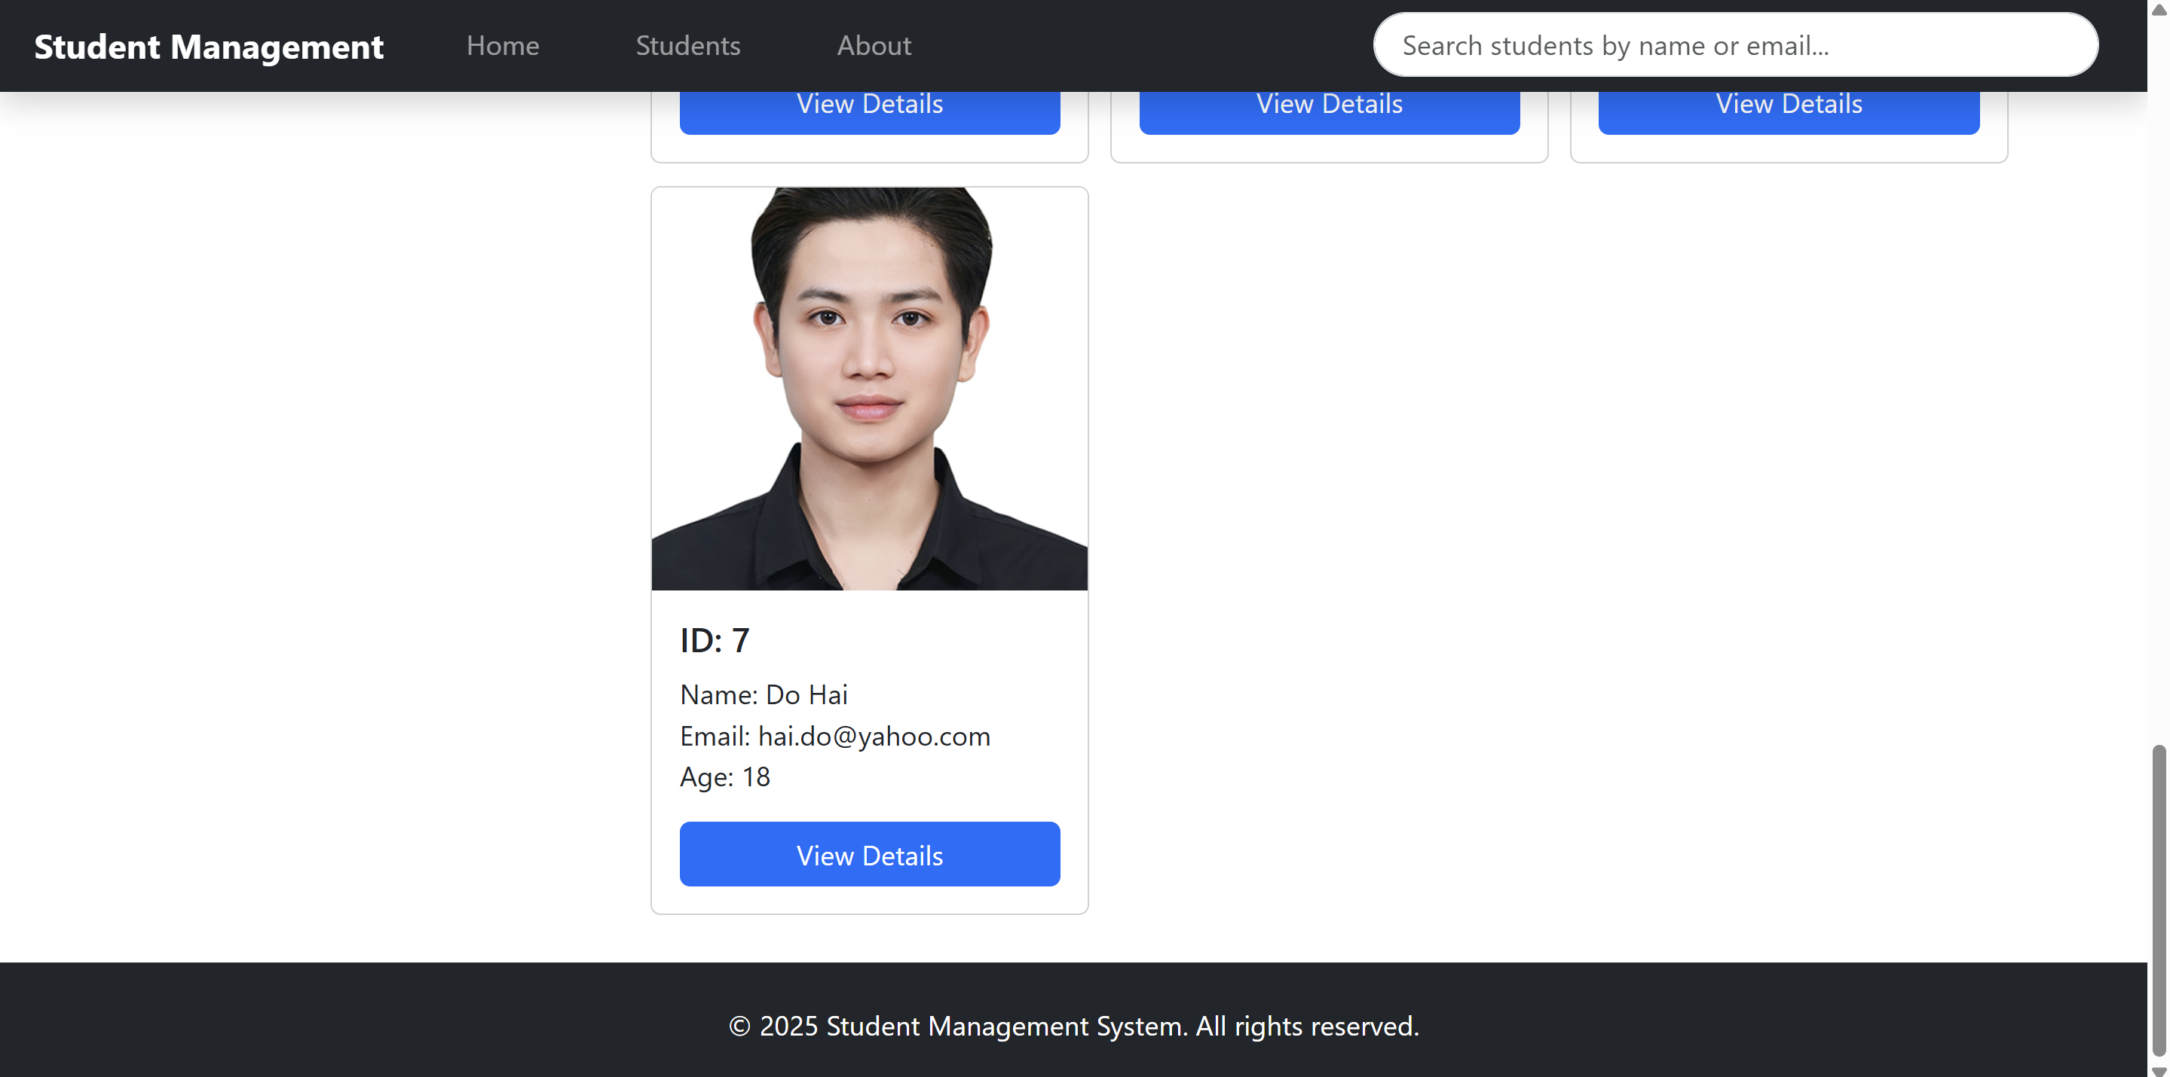

import React, { useState, useMemo } from 'react';

import { Container, Row, Col } from 'react-bootstrap';

import Navbar from '../components/Navbar';

import Filters from '../components/Filters';

import SortDropdown from '../components/SortDropdown';

import StudentGrid from '../components/StudentGrid';

import StudentDetailModal from '../components/StudentDetailModal';

import { students as initialStudents } from '../data/students';

function StudentsPage() {

  const [searchTerm, setSearchTerm] = useState('');

  const [ageRange, setAgeRange] = useState('all');

  const [hasAvatar, setHasAvatar] = useState(false);

  const [sortOption, setSortOption] = useState('nameAsc');

  const [selectedStudent, setSelectedStudent] = useState(null);

  const filteredStudents = useMemo(() => {

    let result = [...initialStudents];

    if (searchTerm) {

      result = result.filter((s) =>

        s.name.toLowerCase().includes(searchTerm.toLowerCase()) ||

        s.email.toLowerCase().includes(searchTerm.toLowerCase())

      );

    }

    if (hasAvatar) {

      result = result.filter((s) => s.avatar);

    }

    if (ageRange !== 'all') {

      if (ageRange === '<=20') result = result.filter((s) => s.age <= 20);

      else if (ageRange === '21-25') result = result.filter((s) => s.age >= 21 && s.age <= 25);

      else if (ageRange === '>25') result = result.filter((s) => s.age > 25);

    }

    return result.sort((a, b) => {

      if (sortOption === 'ageAsc') return a.age - b.age;

      if (sortOption === 'ageDesc') return b.age - a.age;

      if (sortOption === 'nameAsc') return a.name.localeCompare(b.name);

      if (sortOption === 'nameDesc') return b.name.localeCompare(a.name);

      return 0;

    });

  }, [searchTerm, ageRange, hasAvatar, sortOption]);

  return (

    <>

      <Navbar onQuickSearch={setSearchTerm} />

      <Container className="my-4">

        <Row className="mb-4">

          <Col>

            <h1 className="text-center">Student Management</h1>

            <p className="text-center text-muted">Manage and explore student information efficiently.</p>

          </Col>

        </Row>

        <Row>

          <Col md={3}>

            <div className="p-3 bg-light rounded shadow-sm">

              <Filters

                onFilter={({ searchTerm, ageRange, hasAvatar }) => {

                  setSearchTerm(searchTerm);

                  setAgeRange(ageRange);

                  setHasAvatar(hasAvatar);

                }}

              />

            </div>

          </Col>

          <Col md={9}>

            <div className="mb-3">

              <SortDropdown onSort={setSortOption} />

            </div>

            <StudentGrid students={filteredStudents} onViewDetails={setSelectedStudent} />

          </Col>

        </Row>

      </Container>

      <StudentDetailModal

        show={!!selectedStudent}

        onHide={() => setSelectedStudent(null)}

        student={selectedStudent || {}}

      />

    </>

  );

}

export default StudentsPage;